Assignment NO 14
Q1 write the the commmand that put the follwing values, in theire given order ,into the salespeople table;
city- san jose, name-blanco , commm-NULL , CNUM ,-11000
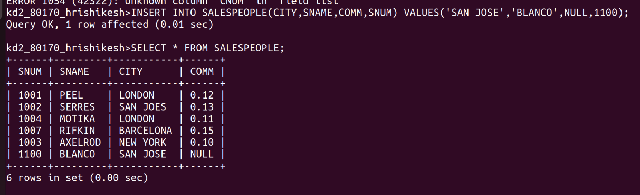
Q2 write command that removes all orders from customers clemens from the orders table;
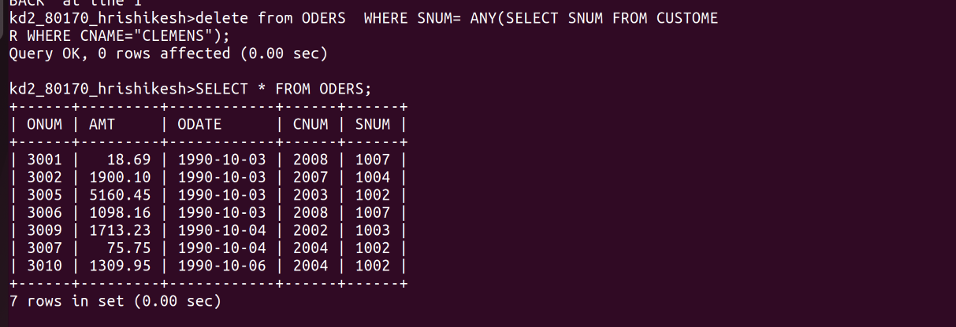

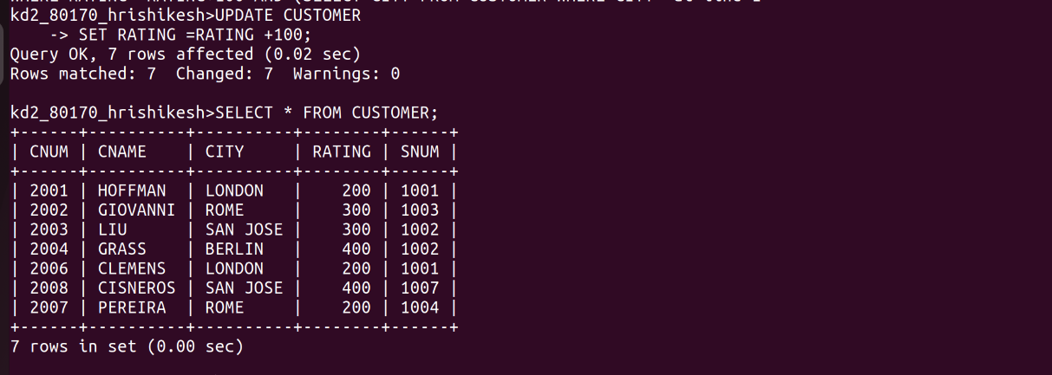
Q3 write the command that increase the rating of all customer in rome by 100;

Q4 SALESPEOPLE SERRES HAS LEFT THE COMPANY ASSIGN HER CUSTOMER TO MOTIKA
